**Lesson3 APP11:**

**Create a Bucket**

**Selecting S3 from the storage of the AWS service panel:**

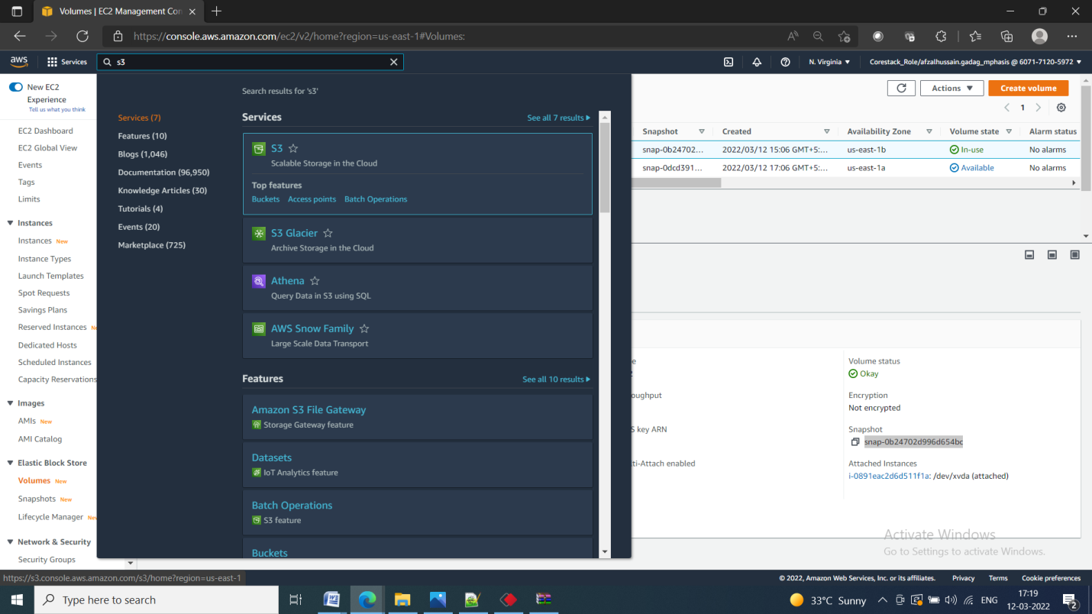

**Verifying the button to create a bucket:**

Providing a bucket name and region

* Make sure that the bucket name is unique

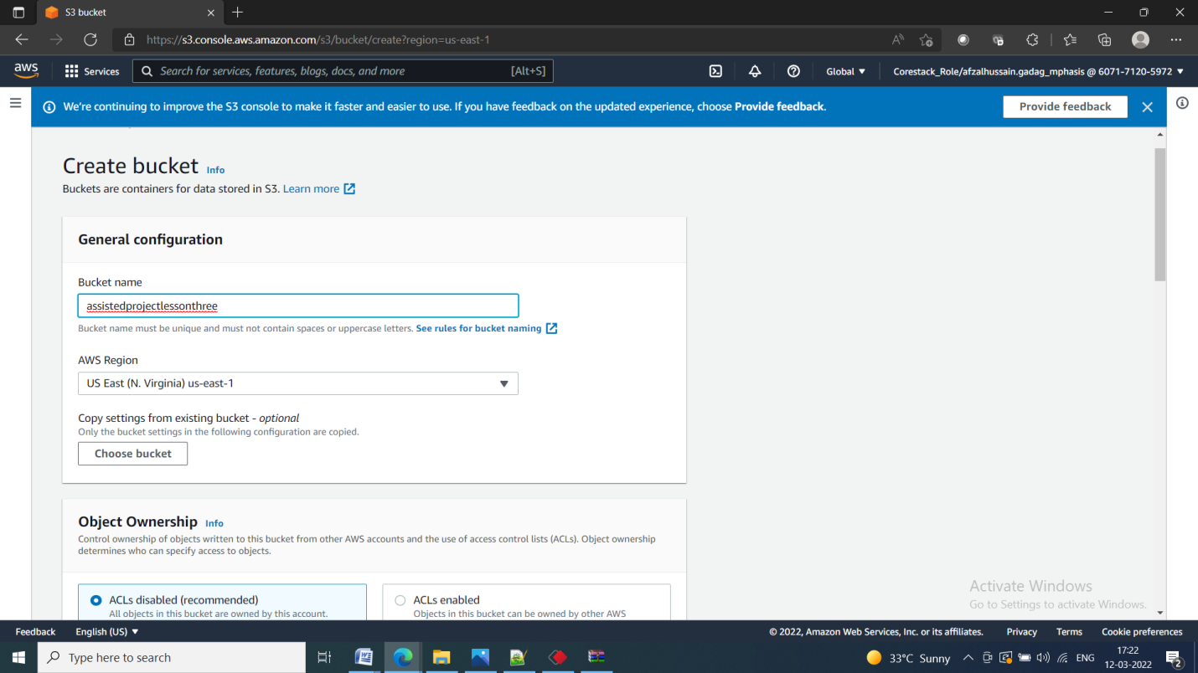

Entering key and value for identification and tracking the bucket

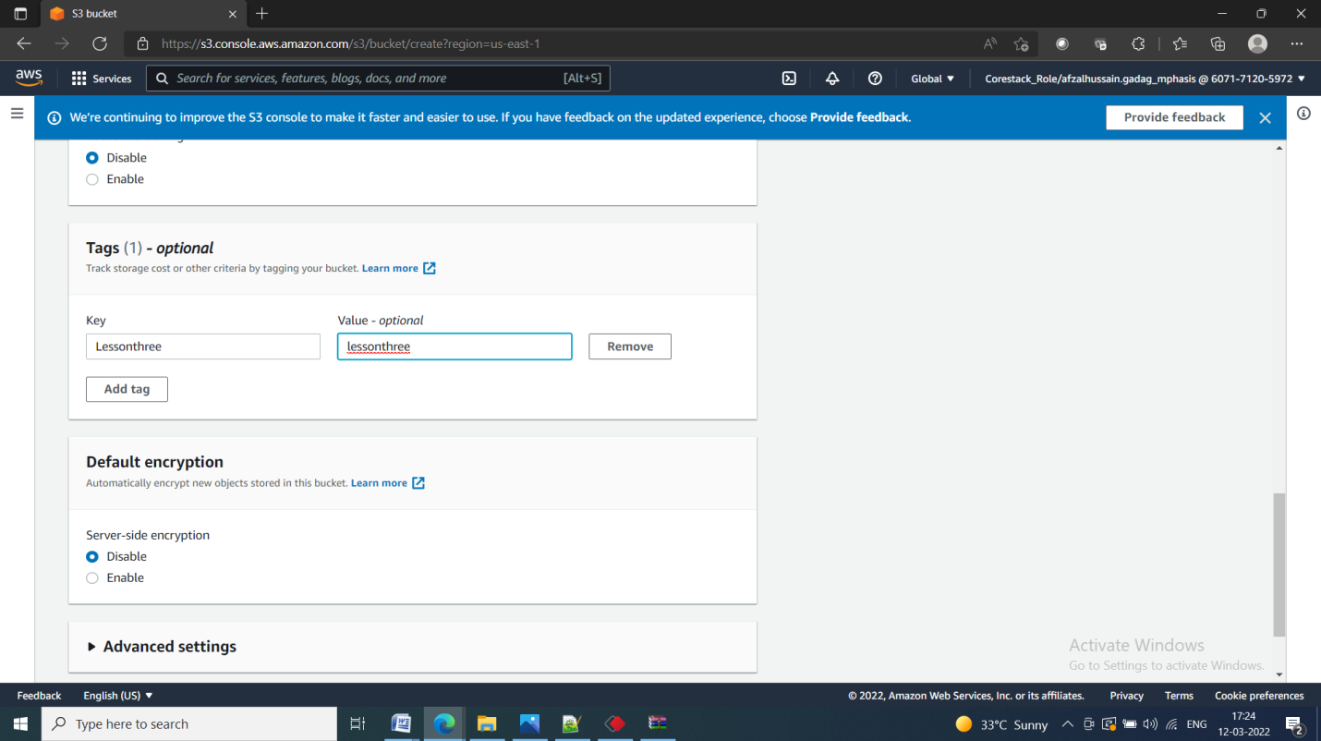

**Blocking all the public access:**

* If required, you can configure it later

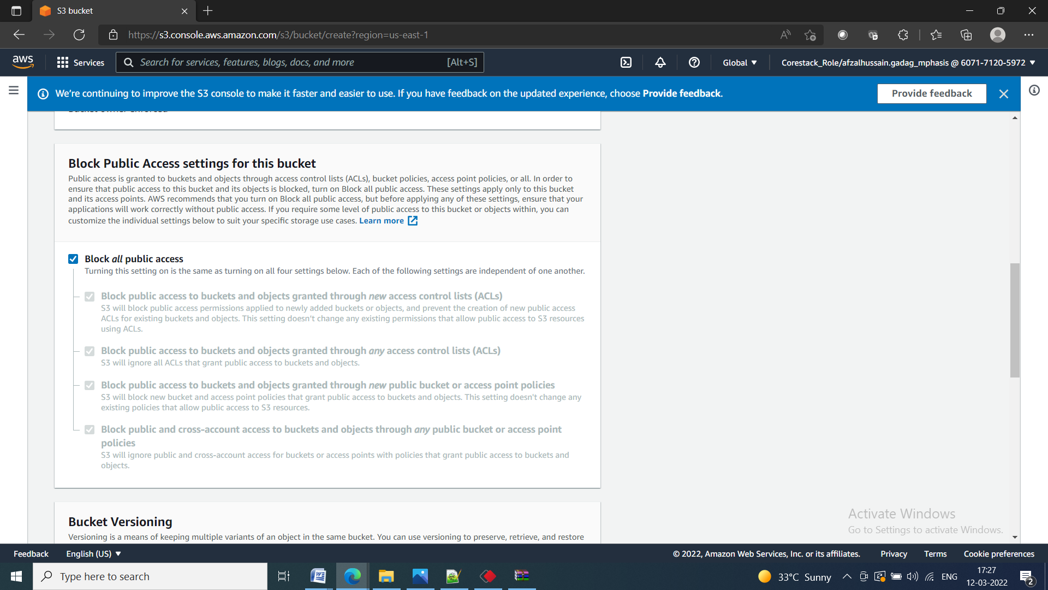

**Reviewing all parameters and creating the bucket :**

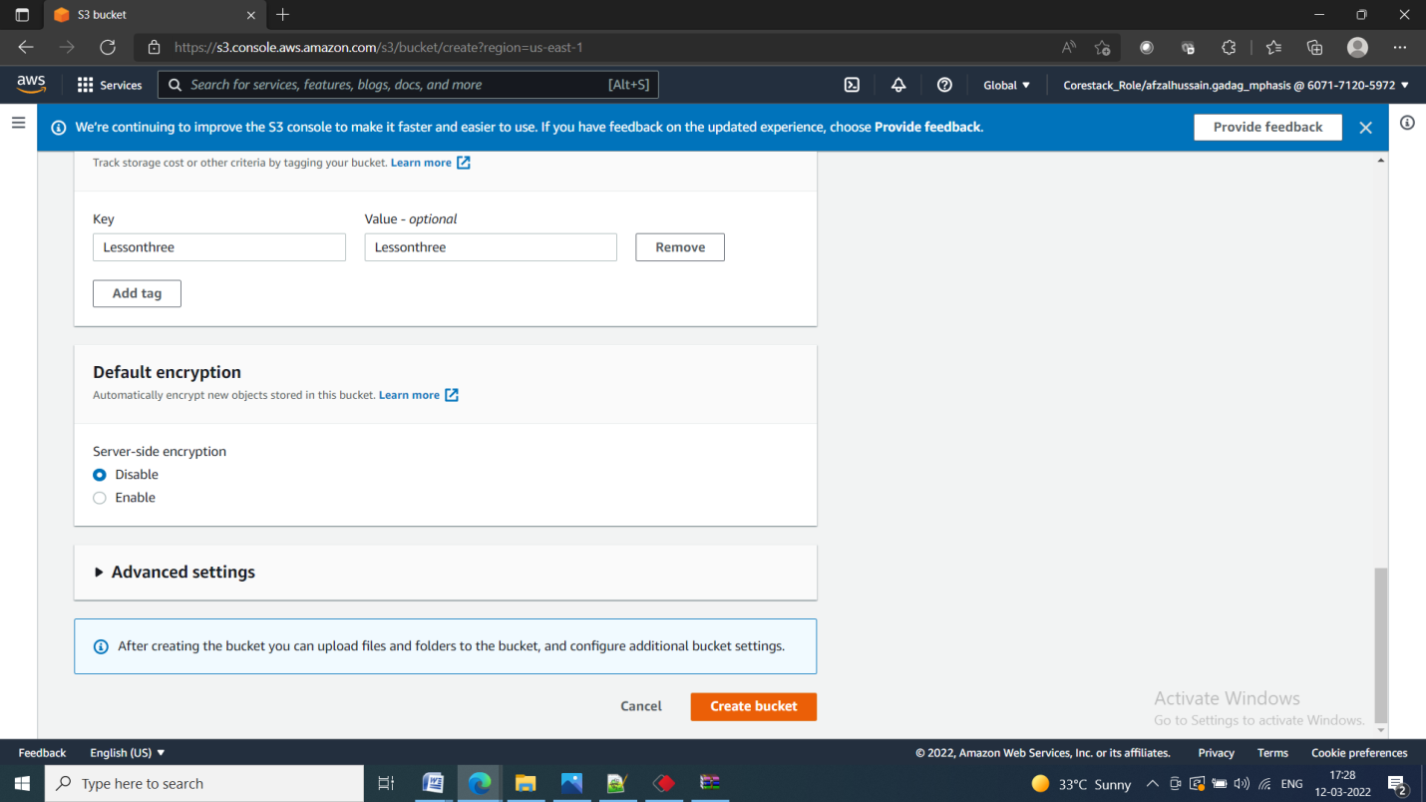

**Verifying the newly created bucket on the panel of S3:**

